WEB 2

DESIGN DOCUMENT

SUMMARY

We are creating a simple website that displays DEPARTMENTS, EMPLOYEES and TASKS with the use of Angular, Node.js and Typescript. The main page features the DASHBOARD which shows information about all 3 components at the same time as well as a calendar which would show the start and end of different tasks. These components also have interactions with each other in parent-child relationships. There is also a navigation bar that helps for better access to the different sections. Once inside the page for a component the website displays all objects of said component and offers CRUD functionalities. In the navigation bar there is also a search option so it’s even easier for the user to access a certain department, employee or task depending on their needs.

SITE MAP

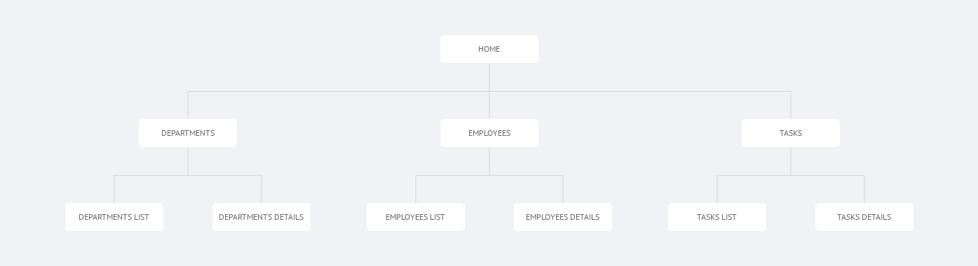

WIREFRAMES